***EXPERIMENT -1: Linux Commands and C programming***

***Objective****: To familiarize Linux Commands and demonstrate a clear understanding of the C-programming environment.*

*1.****uname****- Used to get the user name.*

**

*2.****uname -r*** *-Give little bit information about user.*

**

*3.****uname -a****-Give all the available information about user.*

**

*4.****pwd****-Used to check the current present directory.*

*5.****touch <filename>-*** *used to create document.*

**

*6.****ls*** *-used to list all the available directories.*

**

*7.****mkdir <name>-****Used to create directory.*

**

*8.****rmdir <name>-****Used to remove directory.*

**

*9.****cd <name>****-Used to change the directory. It is also used to convert user directory to root directory.*

**

*10.****cd ..-*** *Used to convert user directory to root directory.*

*11.****ls -l <name>****-Used to check the permissions Given to <name> directory.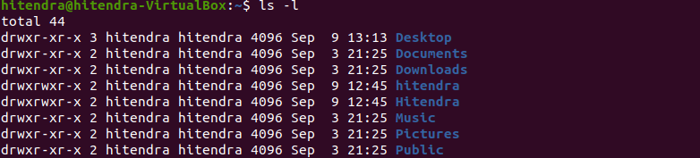*

*12.****cumod <command> <name>****-Used to change the permissions of the directory. 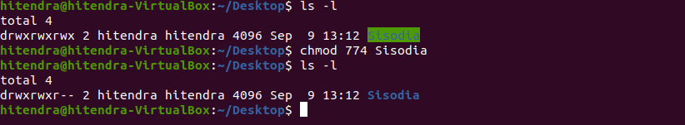*

*13.****history*** *-Used to Check all previous commands.*

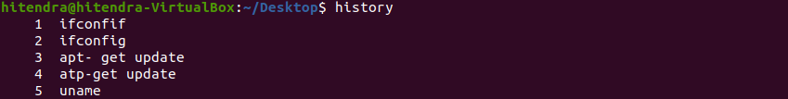

*14.****clear*** *-Used to clear the screen.*

**

*15.****ls -a****-Used to read the hidden directory.*

**

*16.****cat>file****-Used to insert content in the file.*

**

*17.****rm <file name>****-Used to remove the file.*

**

*18.****rm -r <filename>-****Used to remove directory.*

**

*17****.more <filename>****- Used to display all content present in file.*

**

*18.****head <filename>****-Used to display top 10 lines present in the file.*

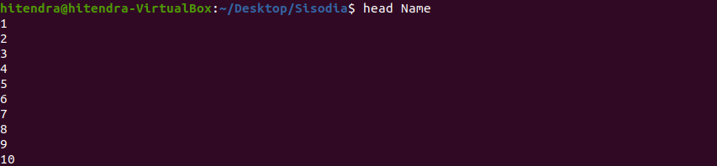

*19.****tail <filename>****-Used to display last 10 lines of file.*

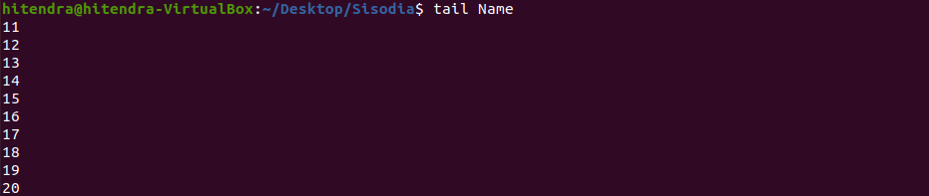

*20.****cp <file1name> <file2name>****-Used to copy the content of file1 to file2.make the file if file2 is not present.file 1 content remain same.*

**

*21.****cp -r <dir1> <dir2>****-Used to copy th content of directory1 to directory2. Dir2 is created if not present.file1 content remain same.*

**

*22.****mv <file/,dir1><file2/dir2>****-Move file1 to file2 if file2 is an file.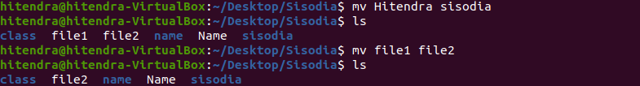*

*Q1 – Print your name and show the output.?*

*Sol-*

***Souce code****:-*

*#include<stdio.h>*

*int main()*

*{*

*printf("My Name is Hitendra Sisodia\n");*

*return 0;*

*}*

***Output****:-*

**

***ALGORITHM***

*Algorithm for purchasing a book in mall*

*Step1-Get dressed*

*Step2-Check there is money in the wallet or not*

*Step3-If not then put money in the wallet*

*Step4-Take wallet and leave home for mall*

*Step5-Go inside mall*

*Step6-Go to book counter*

*Step7-Select a book you want to purchase*

*Step8-Make the payment*

*Step9-Come back home and enjoy reading*

***ALGORITHM***

*Algorithm for taking admission in university*

*Step1-Open internet*

*Step2- select the browser for searching university*

*Step3-open the sites of university one by one*

*Step4-choose a university in which you want admission*

*Step5-fill the application form of the university and submit*

*Step6-pay the fees of application form*

*Step7-fill the registration form and choose the course*

*Step8-pay the fees of semester 1*

*Step9-start attended classes in the campus*

***Experiment 2:-Basic of problem solving and Program Control Flow***

*Q1 – Given to numbers. calculate sum, difference, multiplication and Division?*

*Sol-* ***Algorithm***

*Step1-Start*

*Step2-Declare variables num1,num2 & sum, division, product*

*And difference*

*Step3-Read the values for num1 and num2.*

*Step4-add, subtract, multiply, divide num1 and num2.*

*Step5-Display add, subtract, multiply, divide and exit.*

***Source code***

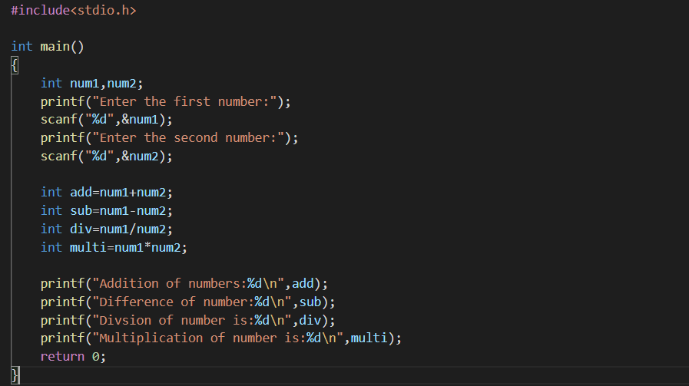

***Output*** 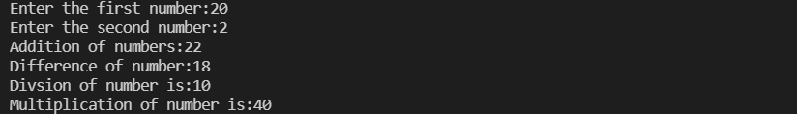

***Flow Chart***

Start

Division=X/Y

Display “Division”

Read X, Y

Division=X/Y

Sum=X+Y

Mult=X*Y

Diff=X-Y

Display “Division”

Display “Sum”

Display “Mult.”

Display Diff.

*Q2- Find the given number is even or not?*

*Sol-* ***Algorithm***

*Step1-Start*

*Step2-Read: Numbers (taking input)*

*Step3-Check: If number%2==0 Then Print N is an even number*

*Else Print N is not an even number*

*Step4-Exit*

***Source code***

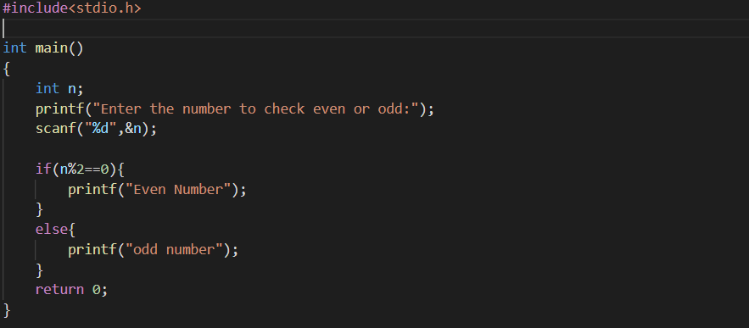

***Output***



***Flowchart***

Start

Input Number

If

Number%2==0

Yes No

Display

“Even Number”

Display

“Not an Even NUMBER”

End

*Q3- Find the biggest of three numbers?*

*Sol-* ***Algorithm***

*Step1-Start the program.*

*Step2-Declare variable num1, num2 & num3.*

*Step3-If num1>num2 go to step4 otherwise go to step5.*

*Step4-If num1>num3 set largest value=num1 otherwise largest value=num3.*

*Step5-if num2>num3 set largest value=num2 otherwise largest value=num3.*

*Step6-End*

***Source code***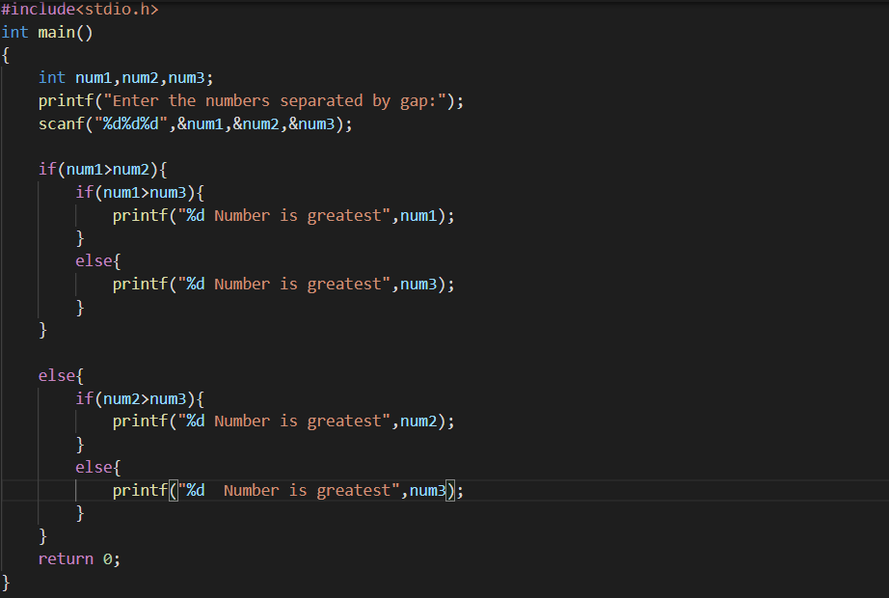

***Output****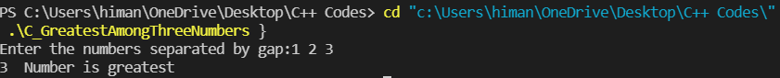*

***Flowchart***

Start

Read the three numbers as num1, num2, num3

Is

Num1>num2

No Yes

Is

Num2>num3

Is

Num1>Num3

No No

Yes Yes

Print

“B is the largest Number”

Print

“C is the largest Number”

Print

“A is the largest number”

End

*Q4-Multiply two numbers without using arithmetic multiplication*

*Operator (*)?*

*Sol-* ***Algorithm***

*Step1-Start*

*Step2-read two numbers.*

*Step3-Print the first number and scan it and print the second*

*Number and scan it.*

*Step4-now print the product using %d function.*

*Step5-and return the first number.*

*Step6-Exit*

***Source code***

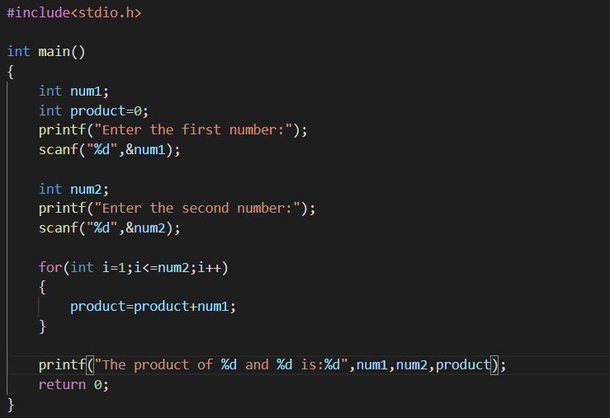

***Output***



***Flowchart***

Start

Input num1,num2,product

Int i=1

Check i<=num2 ?

Yes No

Product=product+num1

Print product

End

***Experiment 3- Programming Sequential Logic***

*Q1-Obtain the required input and compute the area of following*

*Shapes?*

1. *Parallelogram (with base and height)*

*Sol-* ***Algorithm***

*Step1-Start the program.*

*Step2-declare three variables base, area and altitude using float*

*function.*

*Step3-then provide the base and height of parallelogram to the*

*compiler.*

*Step4-compiler will compile the result and provide area of given*

*Parallelogram.*

***Source code***

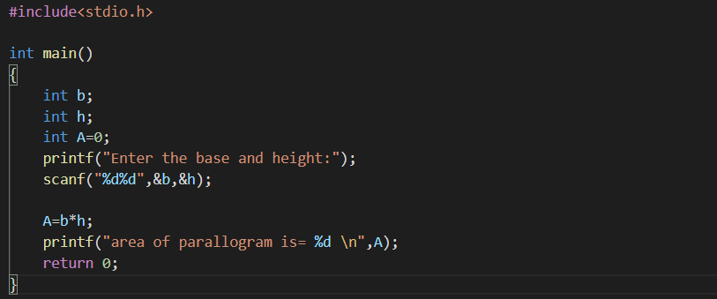

***Output***

1. *Trapezoid ( with height, long base and short base)*

*Sol-* ***Algorithm***

*Step1-Start the program.*

*Step2-declare four variables base1, base2, height & area*

*Using float function.*

*Step3-then provide the two bases and height of the trapezoid*

*To the compiler.*

*Step4-compiler will compile the result and provide the area of*

*given trapezoid.*

***Source code***

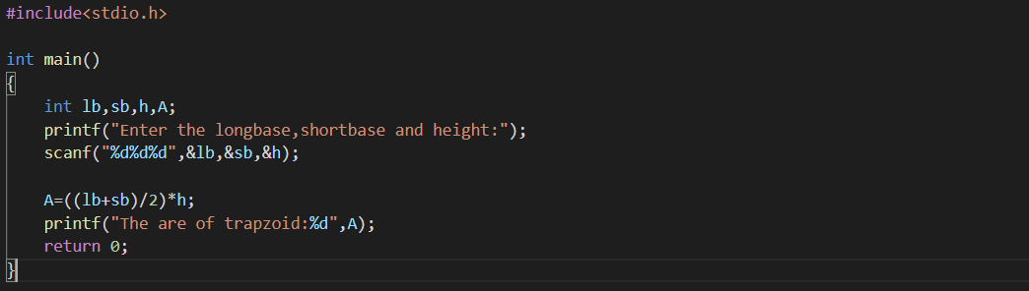

***Output***



1. *Rhombus (with height and side)*

*SOL-* ***Algorithm***

*Step1-Start the program*

*Step2-declare three variables d1, d2 & area using float func.*

*Step3-now provide the two diagonal of the Rhombus to the*

*Compiler.*

*Step4-compiler will compile the result and give the area of*

*Rhombus.*

***Source code***

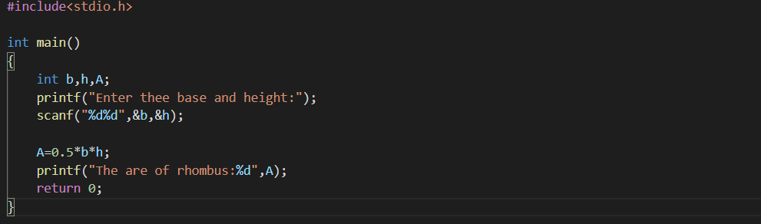

***Output***



1. *Sphere (with radius)*

*Sol-*  ***Algorithm***

*Step1-Start the program*

*Step2-declare two variables r, area and assign PI as 3.14*

*Step3-provide the radius of the sphere to the compiler.*

*Step4- the compiler will compile the result and give the area*

*Of sphere.*

***Source code***

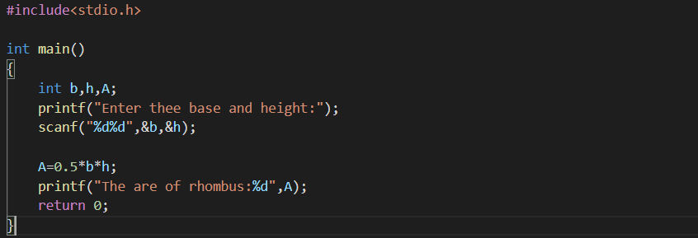

***Output***



1. *Ellipse(with major and minor radius)*

***SOL- Algorithm***

*Step1-Start the program.*

*Step2-declare three variables a, b with int and area with float*

*Function.*

*Step3- now provide the two radius a and b to the compiler*

*Step4-the compiler will compile the result and give area of*

*Ellipse.*

***Source code***

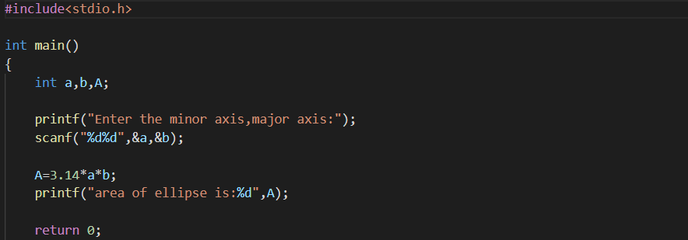

***Output***



*Q2-Given two numbers. Demonstrate the swapping of the values?*

1. *Using a third variable*

*Sol-* ***Algorithm***

*Step1-Star the program*

*Step2-now assign three variables a, b & temp using int func.*

*Step3-now when programming assign a as b and b as temp*

*where temp is the third variable used in swapping.*

*Step4-now provide numbers a and b to the compiler and*

*Run it.*

*Step5-compiler will show the swapped values of a and b*

***Source code***

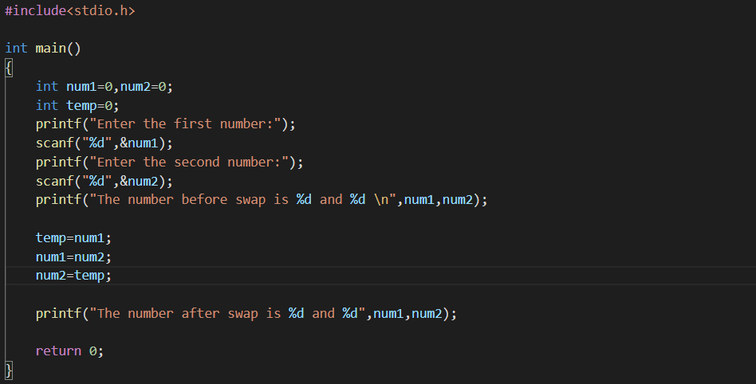

***Output***



1. Without using third variable

Sol- **Algorithm**

Step1-Start the program

Step2-assign the values to two variables a as 10 and b as 20

Using int function.

Step3-now complete the program and run it.

Step4-compiler will compile and show the result.

***Source code***

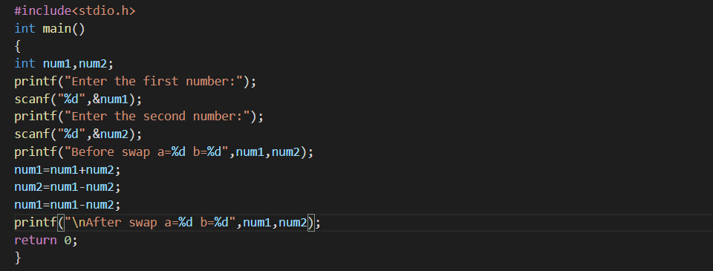

***Output***



*Q3-Convert the temperature from Celsius to Fahrenheit and kelvin?*

*Sol-* ***Algorithm***

*Step1-Start the program.*

*Step2-assign three variables Celsius, farar, kelvin using float*

*Function.*

*Step3-write the formulas to change Celsius into fahr & kelvin.*

*Step4- now run it and assign the value of Celsius.*

*Step5- compiler will compile and change given temperature*

*Into Fahrenheit and kelvin.*

***Source code***

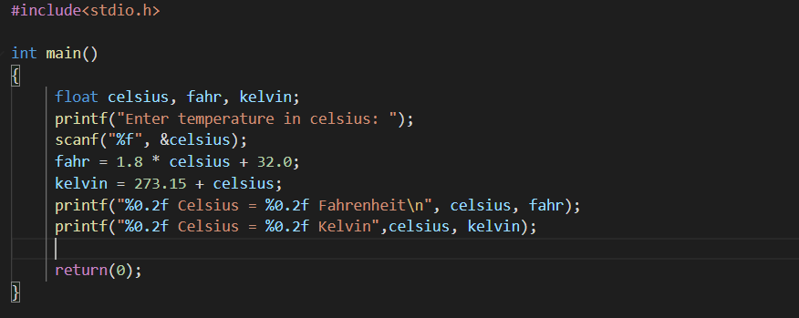

***Output***

**

*Q4-Print the given days in years-month-day format?*

*Sol-* ***Algorithm***

*Step1-Start the program.*

*Step2-assign 3 variables as y, m, d using int function.*

*Step3-write a full code format to display total days into year*

*, month & days.*

*Step4-now the run the program and assign total days.*

*Step5-compiler will compile and write days into year months*

*And days.*

***Source code***

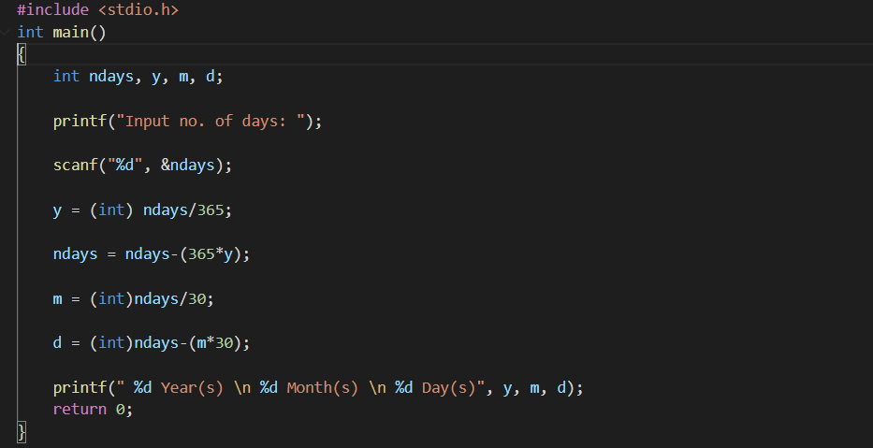

***Output***



***Experiment 4-Conditional Branching***

*Q1-Find the greatest among three numbers?*

*Sol-*

***Source code***

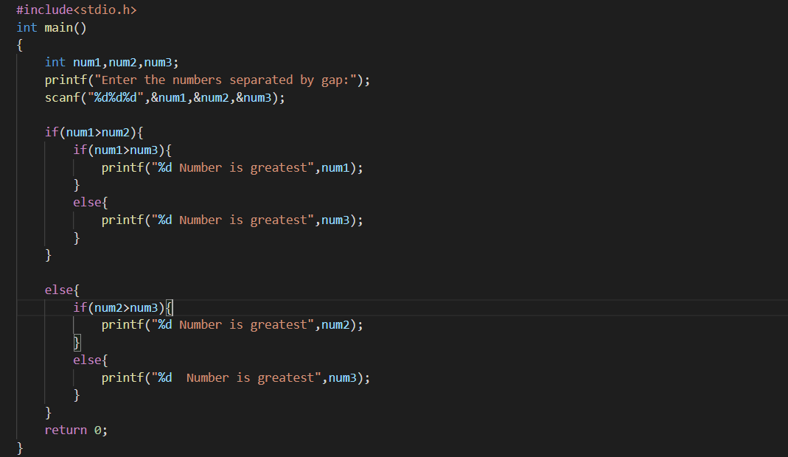

***Output***



*Q2-Check Weather an given year is leap year or not?*

*Sol-*

***Source code***

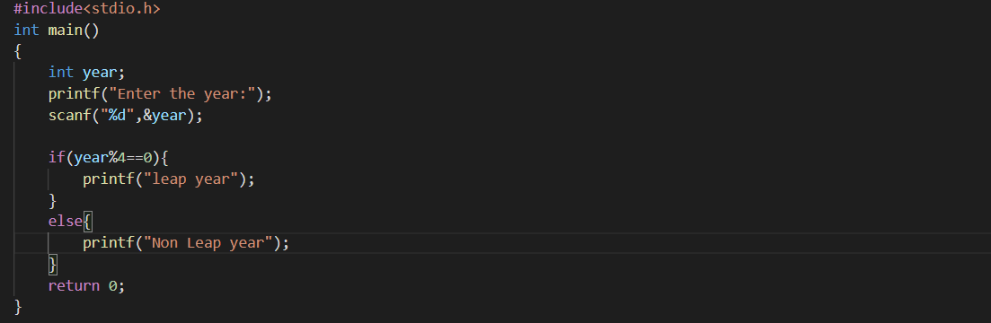

***Output***



*Q3-Check if the given number is divisible by 2 and 3 or not?*

*Sol-*

***Source code***

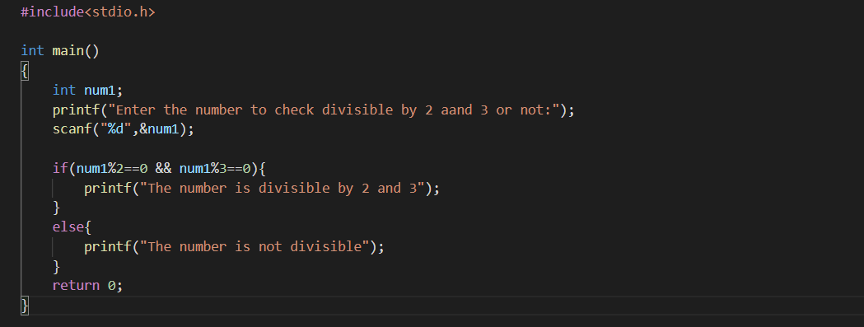

***Output***



*Q4-Check whether a given character is vowel or consonant using switch statement?*

*Sol-*

***Source code***

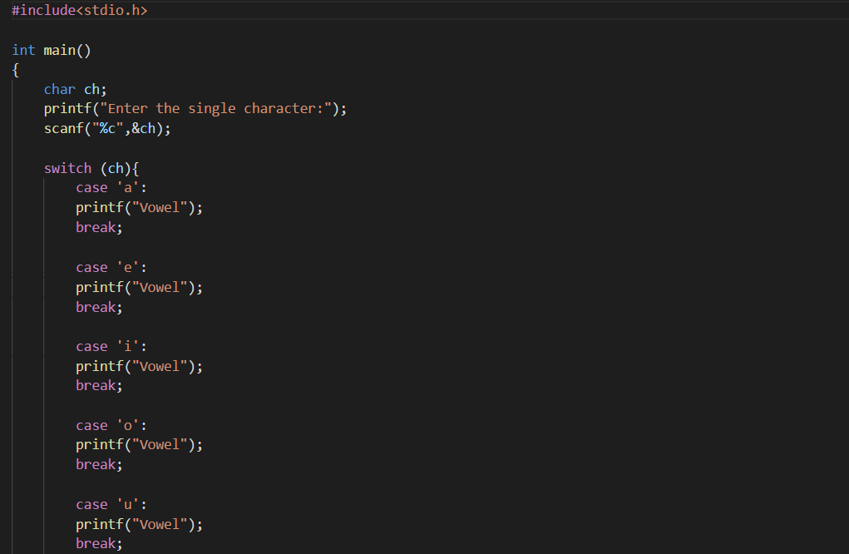

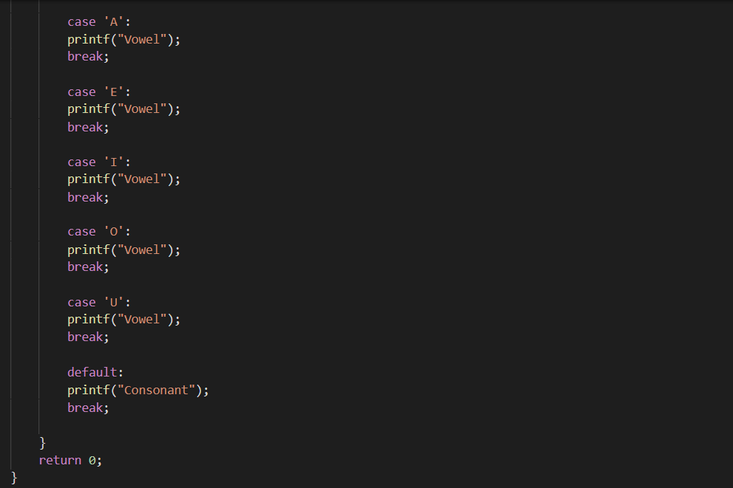

***Output*****

***Experiment 5-Working with Loop/ Iterations***

*Q1-Program to generate Armstrong number between 1 and n?*

*Sol-*

***Source code***

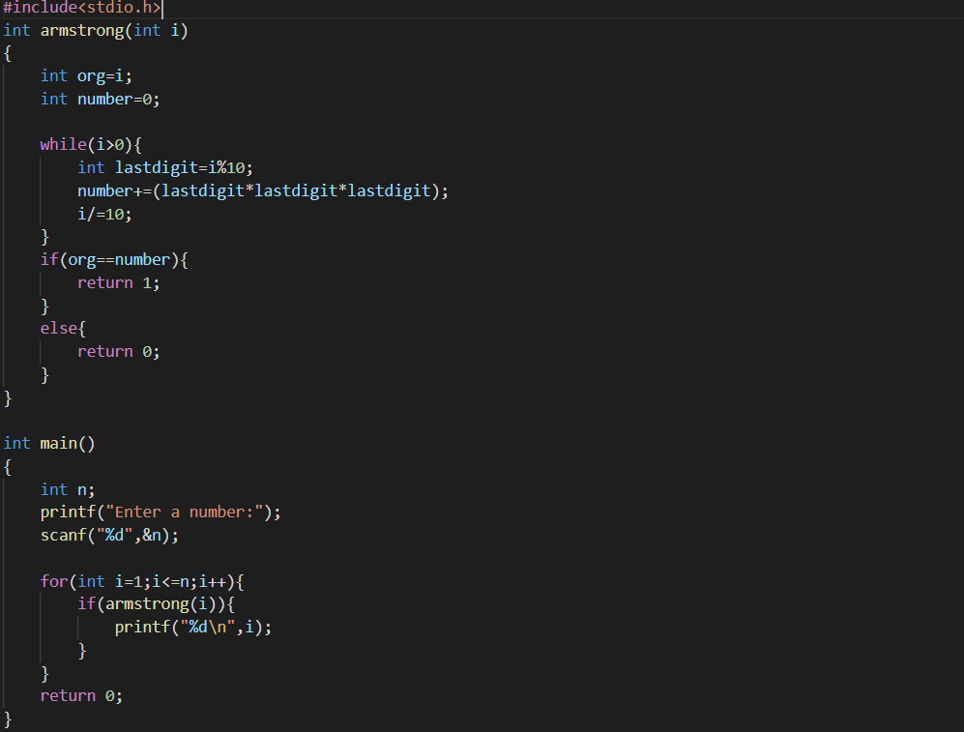

***Output***

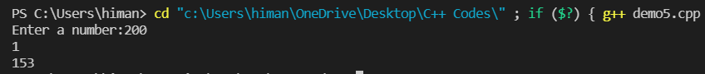

*Q2-Multiply two numbers without using arithmetic binary operators using for loop?*

*Sol-*

***Source code***



***Output***



*Q3-Find the sum of digit in an given number using while loop?*

*Sol-*

***Source code***

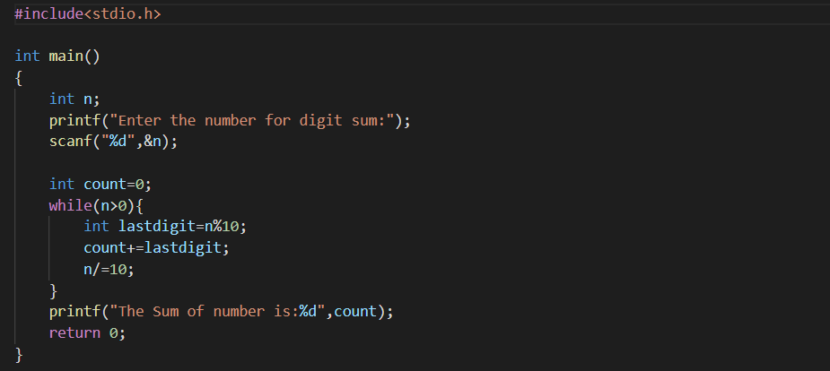

***Output***



*Q4-* *Given value of ‘n’, find the sum of the series 1+ 1/2 + 1/3 + …. 1/n?*

*Sol-*

***Source code***

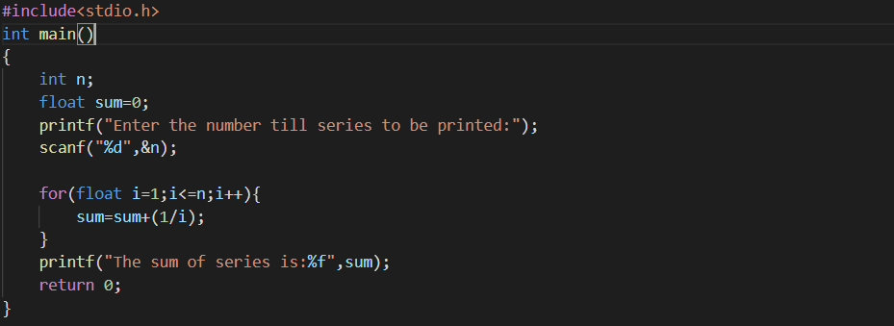

***Output***



*Q5-* *Practice the given pattern using nested for loop?*

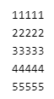

*Sol-*

***Source code***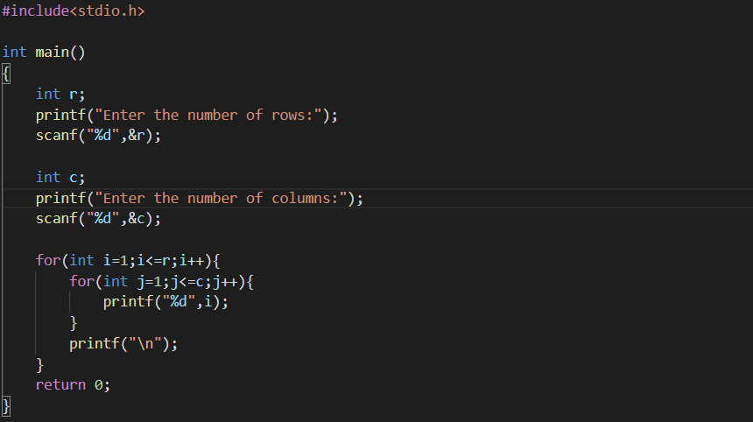

***Output***

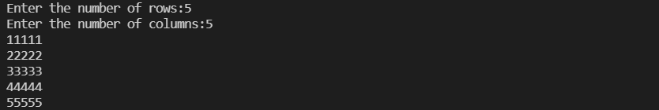

***Experiment 6-Functions, Recursion and Pointers***

*Q1-* *Function main() gets a number and calls the following three functions*

*a. “void armstrong(int)” checks if the given number is a Armstrong number or not.*

*b. “void coprime(int) reverses the given number and checks if the given number and reversed number are coprime.*

*c. “int factorial(int) computes the factorial of the given number using recursion and returns to main().*

*Sol-*

***Source code***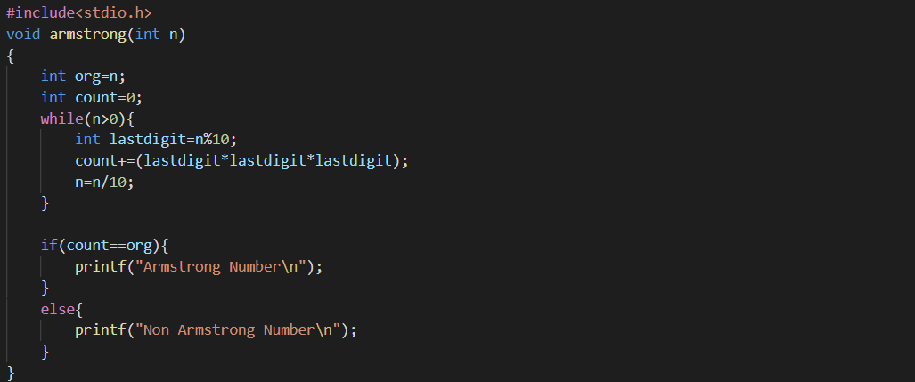

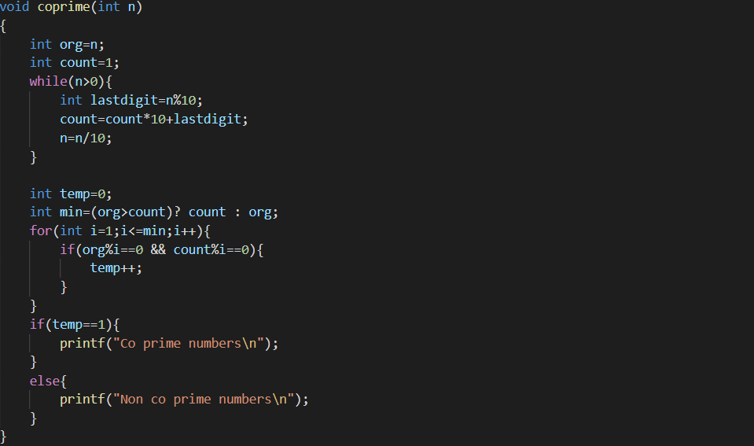

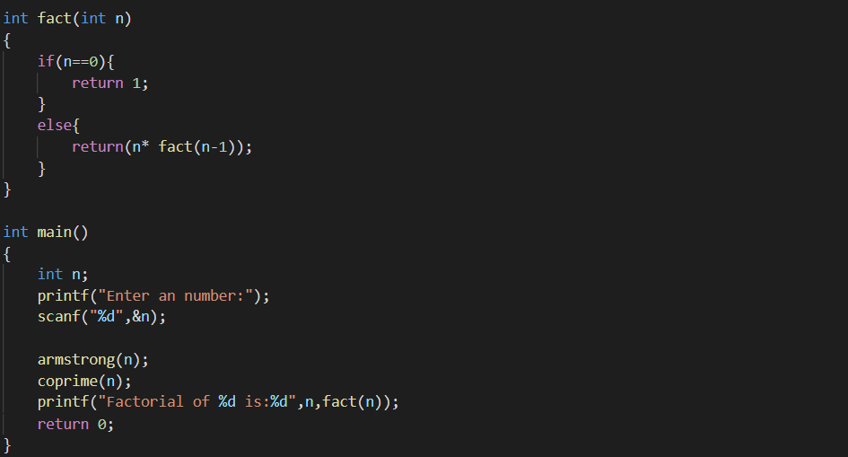

***Output***

*Q2-* *Function main() gets two numbers from the user and calls three functions in the given order:*

*a. “int triangle_area(int base, int height)” returns the area of the right-angled triangle to main().*

*b. “void swap(int *, int*)” swaps the two numbers using bitwise operator and displays them.*

*c. “float* remainder (int a, int b)” returns the remainder of a/b to main().*

*Sol-*

***Source code***

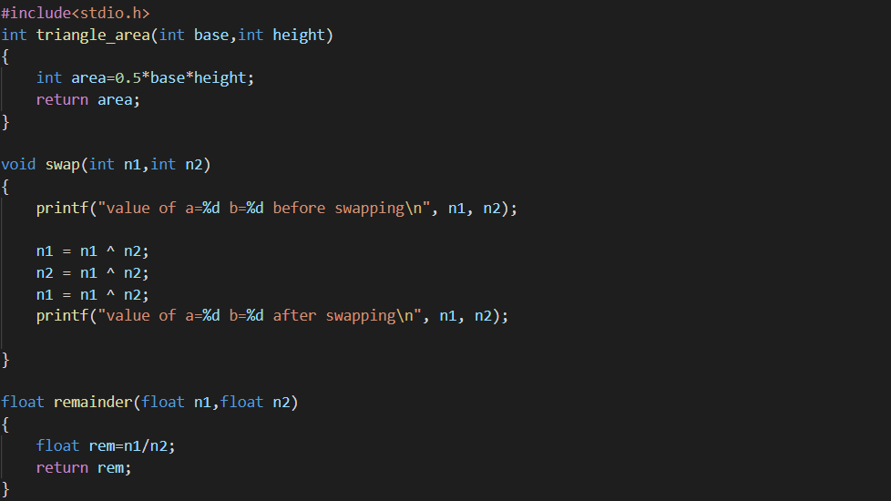

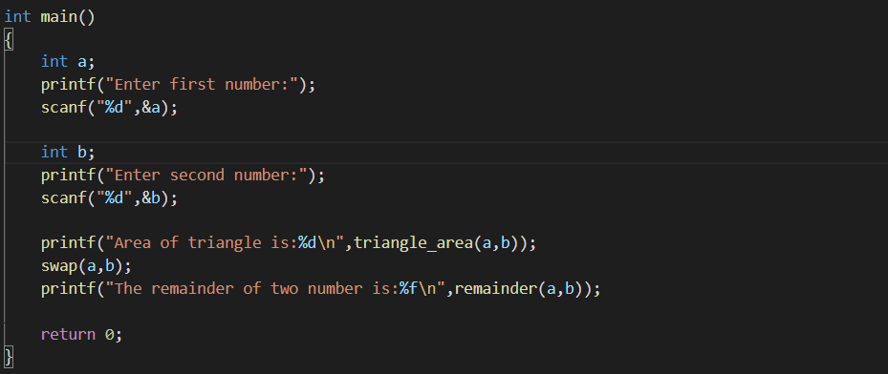

***Output***

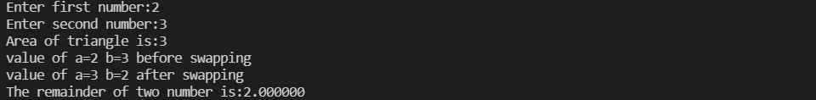

***Experiment 7-*** ***1D Arrays & Strings***

*Q1-* *Find sum of all array elements using recursion.*

*Sol-*

***Source code***